DNA/Protein Sequence Analysis Using BLAST

1. Introduction
Bioinformatics is the application of computer technology and biological methods to analyses biological data. DNA and protein sequence analysis is an important part of bioinformatics because it helps scientists identify similarities between sequences and investigate their possible biological functions and evolutionary relationships.
BLAST stands for Basic Local Alignment Search Tool. It is used to compare a DNA or protein sequence with sequences available in biological databases. It identifies regions of similarity and provides statistical values that help researchers evaluate the results.
In this practical, the human insulin protein sequence was obtained from the National Center for Biotechnology Information (NCBI) database and analyzed using Protein BLAST (BLASTP).

2. Objectives
The objectives of this practical were:
- To obtain a protein sequence from the NCBI database.
- To perform BLAST analysis to identify similar protein sequences.
- To examine percentage identity, similarity, query coverage, alignment score, and E-value.
- To interpret the results and understand the importance of sequence comparison in bioinformatics.

3. Materials and Methods

Materials
- Computer or laptop
- Internet connection
- NCBI Protein database
- NCBI Protein BLAST (BLASTP)
- Microsoft Word for preparing the report

Method
First, the human insulin protein sequence was selected from the NCBI Protein database. The sequence was obtained in FASTA format and entered into the query box on the NCBI BLASTP webpage.
The BLASTP program was used to compare the query protein sequence against the selected protein database. The default search settings were retained. After submitting the sequence, the search was allowed to complete.
The resulting matches were examined to identify similar proteins. The percentage identity, query coverage, E-value, bit score, and alignment details were recorded from the results. Screenshots of the protein record, BLAST results, and sequence alignment were collected as evidence of the analysis.

4. Results
The BLASTP search produced a list of protein sequences similar to the selected insulin query sequence. The results were evaluated using the statistics provided by NCBI.
Query protein: Human insulin preproprotein
Database: ClusteredNR (as displayed in the BLAST results)
Program: BLASTP
Query length: [Enter the length shown in your final results]

Table 1: Summary of BLAST Results
Parameter | Observed result
Parameter | Value to enter
Query protein | Human insulin preproprotein
Program | BLASTP
Database | The database shown on your results page
Query length | 110 amino acids, only if unchanged in your final search
Top matching protein | Human insulin or the actual top hit shown
Organism | As shown in the top hit

5. Discussion
BLASTP was used to compare the selected insulin protein sequence with sequences stored in a biological database. The resulting matches helped demonstrate how sequence similarity searches can be used to study proteins.
Percentage identity indicates the proportion of aligned amino acid positions that contain exactly the same amino acid in both sequences. A higher percentage identity indicates a greater number of exact matches within the alignment.
Similarity can also be assessed using the number or percentage of positive substitutions reported in the alignment. Positives include identical amino acids and certain non-identical amino acids that receive favorable scores because of their chemical properties.
Query coverage indicates the percentage of the query sequence included in the alignment. High coverage means that a large proportion of the query sequence has been aligned with the matching sequence.
The bit score indicates the strength of the alignment, with higher scores generally representing stronger alignments. The E-value estimates how many matches with a similar or better score could be expected to occur by chance in a database search. A lower E-value generally indicates a more statistically significant match.
These parameters should be interpreted together. High sequence identity, substantial query coverage, a high bit score, and a low E-value can support the conclusion that two sequences are closely related. However, sequence similarity alone does not prove that two proteins have exactly the same biological function.
Protein sequence:
>NP_000198.1 insulin preproprotein [Homo sapiens]
MALWMRLLPLLALLALWGPDPAAAFVNQHLCGSHLVEALYLVCGERGFFYTPKTRREAEDLQVGQVELGG
GPGAGSLQPLALEGSLQKRGIVEQCCTSICSLYQLENYCN

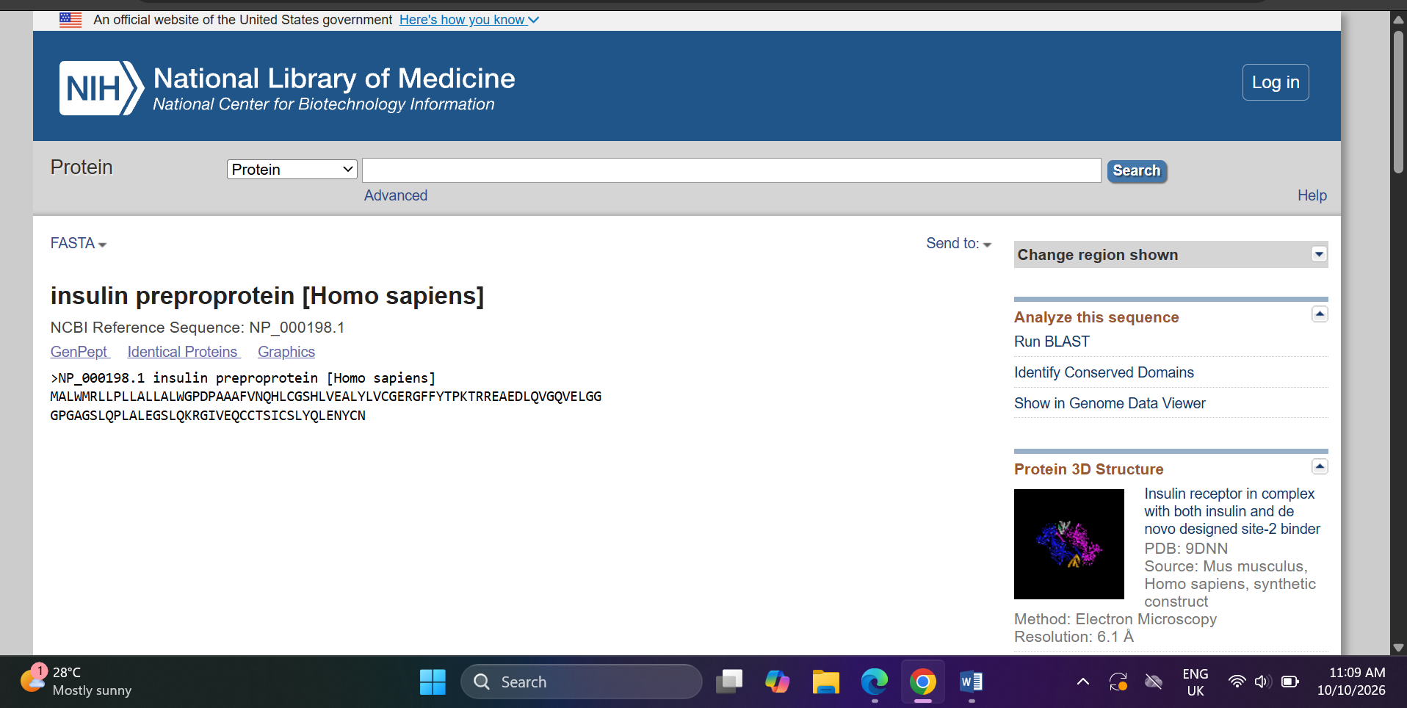

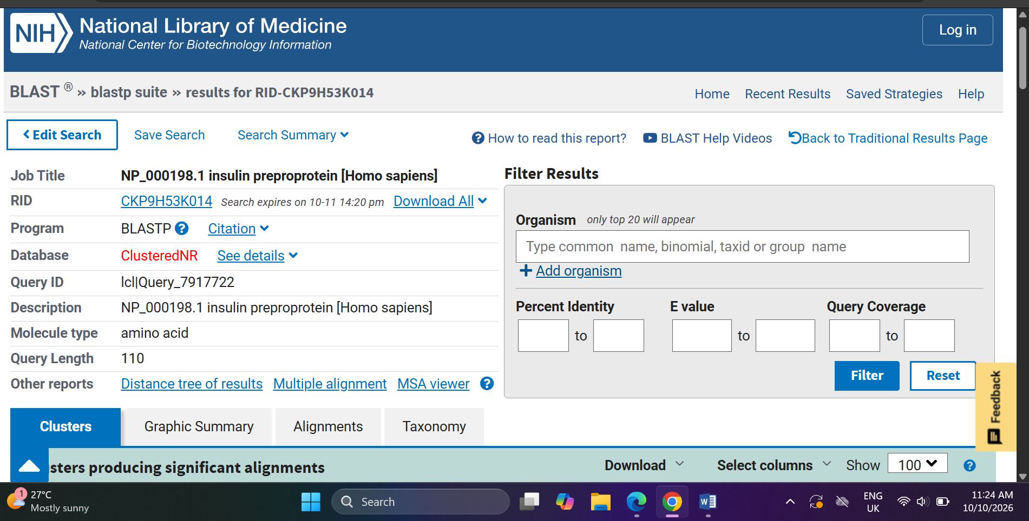

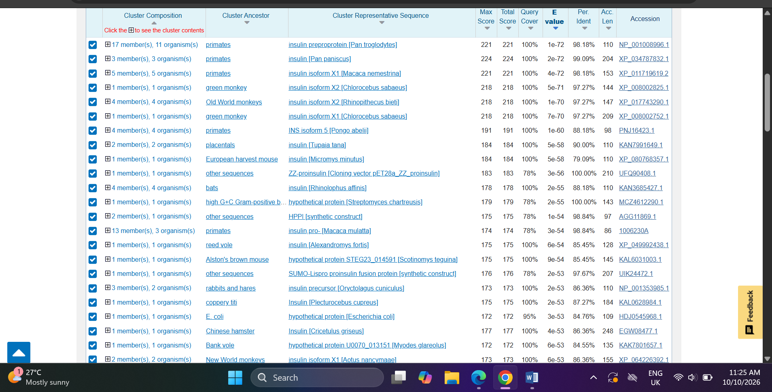

6. Conclusion
In this practical, a protein sequence was obtained from the NCBI database and analyzed using BLASTP. The search identified similar sequences and provided important statistics for comparing the query with database matches.
The practical demonstrated the use of bioinformatics tools in protein sequence analysis. It also provided an understanding of percentage identity, similarity, query coverage, alignment score, and E-value, which are important parameters for interpreting BLAST results.

7. References
- National Center for Biotechnology Information (NCBI). Protein BLAST. Available at: https://blast.ncbi.nlm.nih.gov/Blast.cgi?PROGRAM=blastp&PAGE_TYPE=BlastSearch
- National Center for Biotechnology Information (NCBI). BLAST Help and Frequently Asked Questions. Available at: https://blast.ncbi.nlm.nih.gov/doc/blast-help/FAQ.html
- National Center for Biotechnology Information (NCBI). Human insulin protein record. Available at: https://www.ncbi.nlm.nih.gov/protein/NP_000198.1

